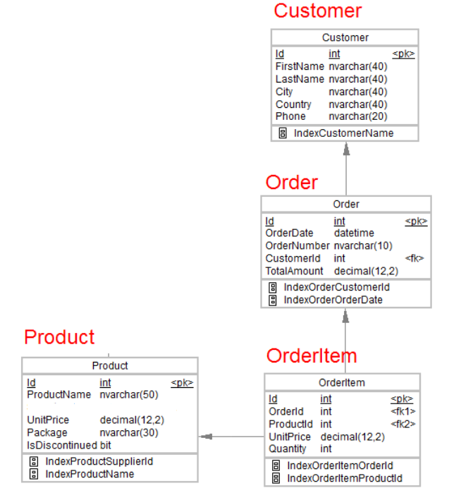

1.Desgin the above database with following table by applying Primary key and Foreign key

Done using graphical method.

Creating table

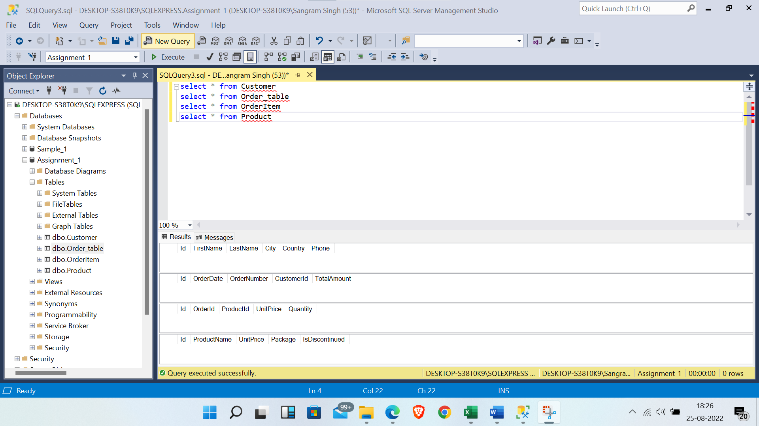

--Applying foreign key

--For fk2

alter table OrderItem

add constraint OrderItem_ProductId_FK

foreign key (ProductId) references Product (Id)

--For fk1

alter table OrderItem

add constraint OrderItem_OrderId_FK

foreign key (OrderId) references OrderTable (Id)

--For fk

alter table OrderTable

add constraint OrderTable_CustomerId_FK

foreign key (CustomerId) references Customer (Id)

2.Insert Records in all tables

--Insertion of records

insert into Customer Values (11010,'Sammy','Singh','New Delhi','India','1234567890')

insert into Customer Values (1011,'Robert','Cullen','Berlin','Germany','1234567800')

insert into Customer Values (112,'Oliver','Mathews','Wuhan','China','1234567790')

insert into OrderTable Values (100,2021-11-07,'1213456',110010,984)

insert into OrderTable Values (101,2020-05-07,'1587982',112,468.25)

insert into OrderTable Values (102,2022-08-18,'8765527',110010,77.77)

insert into Product Values (10,'Shampoo',689.77,'New',0)

insert into Product Values (11,'Soap',25.89,'Bell',1)

insert into Product Values (12,'Olive Oil',787.77,'Best',0)

insert into OrderItem Values (0,101,11,98.77,90)

insert into OrderItem Values (1,100,12,654,8)

insert into OrderItem Values (2,102,10,12.57,77)

3.In Customer table FirstName Attribute should not accept null value

Done

4.In Order table OrderDate should not accept null value

Done

5.Display all customer details

--Display all customer details

select * from Customer

6.write a query to display Country whose name starts with A or I

--write a query to display Country whose name starts with A or I

select Country from Customer

where Country like 'A%'

or Country like 'I%'

7 .write a query to display whose name of customer whose third character is i

--write a query to display whose name of customer whose third character is i

select FirstName from Customer

where FirstName like '__i%'